Edgar Allan Poe: master of mystery
Traits of Dark Romanticism:
- part of American Romantic Period
- took place in early 19th Century (~1840)
- intuition and emotions are more important than logic and reason
- the world is dark and mysterious, humans were prone to sin and self-destruction
- popular supernatural themes - ghosts, devils, vampires, werewolves, etc.

Glossary:  gambling – hazard  merchant – kupiec, handlowiec  rabies – wścieklizna  dreary – ponury | weary – znużony  lore – wiedza  bleak – posępny  chamber – pokój (sypialnia)
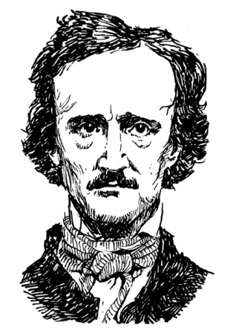

- Choose the correct answer.
He was born in…
A. Boston, on January 19, 1809
B. Boston, on February 19, 1809
C. Boston, on January 19, 1829
Young Edgar gave up his studies and...
A. came back to Allan's home
B. joined to United States Army
C. secretly married his cousin
His first publication was…
A. The Raven
B. Tamerlane and Other Poems
C. The black cat
What was the cause of Edgar's death?
- abusing alcohol
- congestion of the brain
- it’s unknown

- Fill the gaps with one word. The first letter is given to help you.

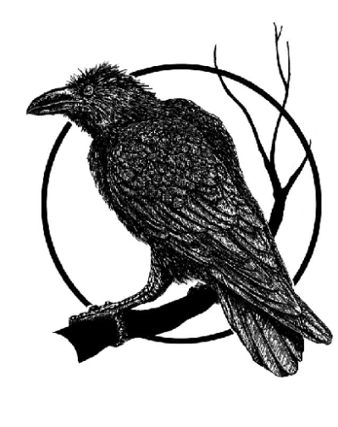
The Raven by Edgar Allan Poe

Once upon a midnight dreary, while I pondered, w___ and w____,
Over many a quaint and c______ volume of forgotten lore -
While I nodded, nearly napping, suddenly there came a t______,
As of some one gently rapping, rapping at my chamber door.
“’Tis some v______,” I m_______, “tapping at my chamber door –
Only this and nothing more.”

