
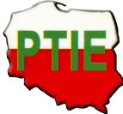
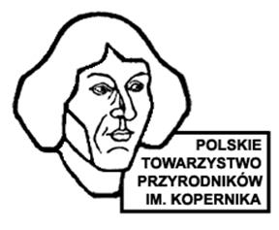
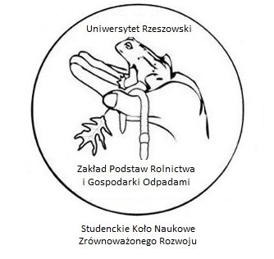


SCIENTIFIC CONFERENCE
"PROSPECTS FOR RENEWABLE ENERGY SOURCES AND WASTE MANAGEMENT"
November 21, 2023 College of Life Sciences,
Institute of Agricultural Sciences, Environmental Protection and Management, Department of the Basis of Agriculture and Waste Management of the University of Rzeszów
1A Ćwiklińska Street, building D3, room 3.41

PROGRAM OF THE MEETING
8.30 – 9.30 Registration of participants (on line from 9.00)
9.30 – 9.40 Opening of the conference:
prof. dr hab. Jadwiga Stanek-Tarkowska – Director of the Institute of Agricultural Sciences, Environmental Protection and Management, College of Life Sciences, University of Rzeszów
prof. dr hab. Joanna Kostecka – Department of the Basis of Agriculture and Waste Management, Tutor of the Students' Scientific Club for Sustainable Development of the University of Rzeszow

Session I:
9.40 – 10.30 Presentations (conducting: prof. dr hab. Joanna Kostecka)

Joanna Kostecka – All hands on deck; let's save the planet
Kevin R. Butt – Sustainable crop production from marginal agroecosystems: A case study from the Isle of Rum, Scotland

Session II:
10.30 – 11.30 Presentations (conducting: dr hab. Mariola Garczyńska, prof. UR, dr hab. Grzegorz Pączka, prof. UR, dr Anna Mazur-Pączka)

Aleksander Walas, Manager of the Department of Development and Environmental Protection, METKOM – Investments in circular economy technologies on the example of Metkom
Arkadiusz Kamiński, Agnieszka Pusz – Water and power engineering in the face of sustainable development challenges and goal implementation
Teresa Noga – Algae and modern technologies

11.30 – 11.50 Coffee break (welcome with your own mug)
11.50 – 14.00 Presentations (conducting: dr hab. Mariola Garczyńska, prof. UR, dr hab. Grzegorz Pączka, prof. UR, dr Anna Mazur-Pączka)

Terms of the competition for the best student speech

Sara Ciapa – Urban green areas and their impact on the air quality and urban heat island effect on the example of the city of Kraków
Szymon Pelczar – Legal changes introduced in 2023 and photovoltaic and wind power plants projects — analysis, interpretation and impact of the amendment of normative acts
Marcel Bajger-Ryba – Kiri tree - oxygen trees are a chance for our planet
Dariusz Kaniuczak, Małgorzata Szostek – Changes in soil physicochemical properties as a result of the use of ashes from biomass combustion applied in various soil moisture conditions
Diana Gałuszka, Daniel Styś – Possibility of recovering waste heat from sewage systems
Martyna Karbowniczek, Adam Masłoń – The utilization of sewage sludge as a source of energy and biogas
Aleksandra Kwasiżur, Małgorzata Kida – Trends and prospects in recycling
Kamil Królikowski, Marcin Fiedur – Limiting fertilizer use in cultivation: Challenges and opportunities for maximizing yield while preserving environmental aspects
Kamil Szawara, Michał Herbut, Bartosz Balawejder, Marzena Mazurek – The potential of the Podkarpackie Voivodeship in terms of specific raw materials for agriculture biogas plants
Radosław Kwarciany, Marcin Fiedur – The energy potential of waste from cut sunflower cultivation
Natalia Bendas – Transformations occurring during the biological stabilization of the fine fraction of mixed municipal waste
Kamila Gierut, Justyna Piekarska – Lumbricidae in selected crops for energy purposes

14. 00 – 14.00 – Conclusions and summary of the conference

