Physics in Kitchen
А.А. Varlamov
Institute of Superconductivity and Innovation Materials (SPIN-CNR), Italy
andrey.varlamov@spin.cnr.it
ABSTRACT
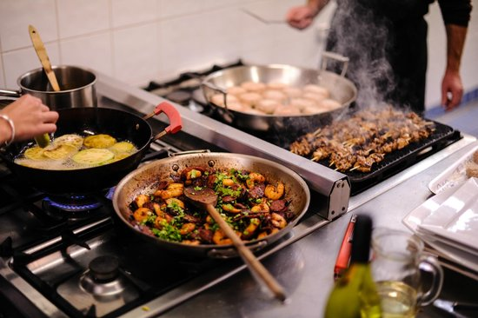

How heat propagates in media, what is the difference between pizza baking in the traditional wood oven and in the electric one, why tastes of the boiled meet and the grilled one are so different, how scientifically calculate cooking time of the soft-boiled duck egg and spaghetti, why cin-cin with crystal glasses filled by sparkling wine is not accompanied by nice canorous sound, why vodka usually contains around of 40 % of alcohol, why professional barman varies the degree of coffee beans grounding depending on weather, and many other questions of surrounding gastronomic universe are discussed in this lecture.
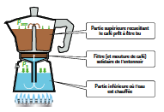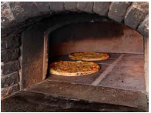

- L.G. Aslamazov, A.A.Varlamov, „”The Wonders of Physics”, WSPC, Singapore, 2012.
- A. Rigamonti, A.A. Varlamov, J. Villain, „Le Kaleidoscope de la Physique”, Belin, Paris, 2014.

